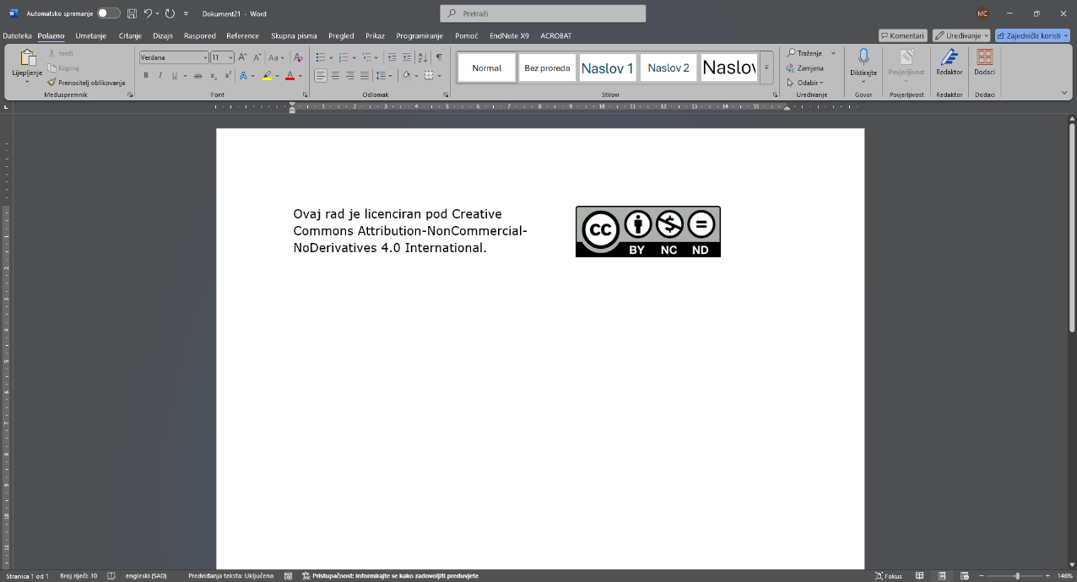
Received: XXXXXX.
Approved for publication: XXXXXX.
Classification of paper
14pt
TITLE OF WORK (Verdana, 14pt, Bold)
14pt
14pt
First Name Last Name ^{1,} First Name Last Name ^{2,}…
¹ University of Slavonski Brod, Trg IB Mažuranić 2, 35000 Slavonski Brod, Croatia,
Email: festung@unisb.hr (Verdana, 10pt)
14pt
Abstract: The title of the paper can have a maximum of 15 words. After the title, the full names and surnames of the authors without titles must be listed. The abstract can have a maximum of 200 words and should faithfully describe the topic of the paper. It is necessary to state the purpose and objective of the paper, the methods used, the results and the contributions of the paper. Keywords must be related to the title and abstract of the paper. The author is responsible for the linguistic and grammatical correctness of the paper. After the review process is completed, the author may be asked to make certain corrections or additions to the abstract and/or paper. (Verdana, 10pt).
10pt
Keywords: alphabetical list of keywords (maximum 6 keywords) (Verdana 10pt)
14pt
14pt
1. Introduction (Verdana, 11, Bold)
11pt
The introduction is the initial or introductory part of the paper in which the author provides initial information about the problem to be solved.
11pt
The introduction provides an overview of the basic characteristics of the problem, the goals that are to be achieved, and the tasks that will lead to the achievement of the planned goals. It is a good idea to state what is known about the problem and what is not. The introduction should not be too extensive.
11pt
2. Methodology (Verdana, 11, Bold)
11pt
Provide a brief overview of possible methods, ways and paths for solving the problem, as well as the limitations that had to be taken into account and respected in the work.
11pt
2.1. Instructions to authors (Verdana, 11, Bold)
11pt
Papers are subject to a double-blind peer review process conducted by domestic and foreign reviewers. As part of the review process, papers published in the journal are classified into one of the following categories: original scientific paper, preliminary communication, review paper, and professional paper. Papers may be in Croatian or English (with the approval of the committee), and abstracts and keywords must be in both Croatian and English.
11pt
Original scientific paper article) contains unpublished results of original theoretical or practical research that the author stated so that their accuracy and the accuracy of the analysis can be checked.
11pt
Preliminary announcement communication) contains material or data that require rapid publication or parts of a larger study.
11pt
review paper. article) a critical and analytical review of a research area or one of its parts. In the article, the author's contribution to the study of the selected issue should be visible, and the cited literature should be complete.
11pt
Professional work paper) contains already known, published results of scientific research and focuses on their application in practice or their dissemination for educational purposes. It contains useful contributions from the field of expertise that are not related to the author's original research, and the observations presented do not have to be new in the field. They must be written in a systematic and understandable manner, in accordance with the reader's profile.
11pt
The editorial board and editor-in-chief decide on the publication of other works (reviews of good practices, conferences and books).
11pt
2.2. Designing the work (Verdana, 11, Bold)
11pt
As a rule, the scope of work should be from 4 to 6 pages, including text, drawings, tables, diagrams, photographs with a list of references without appendices.
11pt
The text of the written part of the paper should be written in two columns, Verdana 11, single-spaced as this text is written. Sentences should be professionally clear, unambiguous and written in the third person singular. All copied parts of the text, images and tables must be cited in accordance with APA style standards (APA 7th edition).
11pt
2.3. Subchapter (Verdana, 11, Bold)
11pt
A chapter in which the results obtained are discussed, the evaluation of one's own solution to the problem is made, other problems that arose during the task are considered, and possible improvements are considered based on one's own experience. How the chapter and subchapter titles will be defined depends on the nature and type of the problem.
11pt
2.4. Figures and tables (Verdana, 11, Bold)
11pt
Figures and tables should be centered and numbered. Figure descriptions should be placed below the figure and table descriptions should be placed above the table.
11pt

Figure 1: Image layout (Verdana, 11pt)
11pt
When placing an image at the top of the page, the top of the image should be flush with the bottom edge of the first line of text. All symbols and letters should be at least 2 mm high. The use of heavy black and/or colored bold letters should be avoided as they will look uncomfortably dark when printed. They should also be placed close to the first reference to them in the text and numbered consecutively. The image caption should be placed immediately below the images. Photographs and images should be prepared in color at a minimum resolution of 300 dpi . Do not use patterns in vector graphics. Images should be prepared in PNG or JPEG format.

11pt
Table 1. Instructions to the authors (Verdana 11)
No. | Name | Description
1. | Paper size | Use A4 paper format (210 x 297) without numbering.
2. | Article size | The paper should be between 4 and 6 pages long.
3. | Margins/columns | All margins should be 2 cm.  Columns should be 8 wide, with a spacing of 1 cm between columns.  A new section should not start directly at the bottom of the page, but the title itself should be carried to the top of the next column; the length of the text area may only be exceeded by one line to complete a section of text or paragraph.
4. | Page layout | The main body of the text should be justified. The page should not end with a title.
5. | Font and line spacing | Verdana, 12pt, single spaced
6. | Title | The title should not exceed 15 words and should be placed on two lines and centered. Title of the paper (Verdana, 14 pt, bold), first and last names of the authors, name of Department, University, Address, City, Country (Verdana, 10pt)
7. | Abstract | The abstract can have a maximum of 200 words and should accurately describe the topic of the paper. It is necessary to state the purpose and objective of the paper, the methods used, the results and the contributions of the paper. Keywords must be related to the title and abstract of the paper. The author is responsible for the linguistic and grammatical correctness of the paper. After the review process is completed, the author may be asked to make certain corrections or additions to the abstract and/or paper. The abstract should be written in Croatian and English (Verdana, 10pt).
8. | Keywords. | alphabetical list of keywords (up to 6 keywords) (Verdana 10pt)
9. | Style | Chapter and subchapter titles (Verdana, 11 pt, Bold), should be left-aligned and numbered. Before and after section titles, place a single 11pt space. Table and figure titles (Verdana 11pt) should be consecutively numbered and centered.
11pt

2.4. Equations (Verdana, 11, Bold)
11pt
Equations should be aligned to the left edge of the column text and should have a blank line before and after.
11pt
(1)
11pt
Equations need to be numbered.
11pt
3. Results and discussion (Verdana, 11, Bold)
11pt
In this section, it is necessary to present in detail the results of one's own research, e.g. research or calculations, illustrating them in detail and legibly with pictures, diagrams, photographs, results, calculations, tables, etc., and stating in detail the cause-and-effect relationships between the stated facts, confirming or refuting data known from the literature. This section should have the character of a scientific discussion, although a separate section can be created for this, and only information on the achieved research results can be included in this one."
11pt
4. Conclusion (Verdana, 11, Bold)
11pt
It is necessary to present the main conclusions and achievements of the research. The author's achievements and originality of the research should be emphasized, as well as the author's contribution to the issues addressed and the value of the study. Practical applications and possible outcomes, as well as directions for further work, can be highlighted.
11pt
5. Literature (Verdana, 11, Bold)
11pt
Formatted according to APA style standards (APA 7th edition), e.g.
11pt
Journal work:
Van Mol, C. (2016). Migration aspirations of European youth and times of crisis . Journal of Youth Studies 19(10), 1303-1320. https://doi.org/10.1080/13676261.2016.1166192
11pt
Book:
Miljković, D. and Rijavec, M. (2002). Better to be a wind than a leaf. IEP.
11pt
Editorial book:
Panian, Ž. and Ćurko, K. (eds .) (2010). Business Information Systems. Element.
11pt
Chapter in the editorial book:
Ciboci, L. and Labaš, D. (2015). The influence of media on the play of preschool children. In D. Smajić, and V. Majdenić (Eds .), Child and language today - child and media (pp. 363-388). Josip Juraj Strossmayer University of Osijek, Faculty of Education.
11pt
Published doctoral dissertation or graduate thesis:
Ergović, Z. (2020). The relationship between social media use and mental health among students during the coronavirus pandemic [Master's thesis, University of Zagreb]. Repository of the Faculty of Croatian Studies. https://urn.nsk.hr/urn:nbn:hr:111:312140
11pt
Unpublished doctoral dissertation or master's thesis:
Bartolović, V. (2020). The workforce of the future – problems and opportunities of the student population [Unpublished doctoral dissertation]. Josip Juraj Strossmayer University of Osijek, Faculty of Economics in Osijek.
11pt
Else:
European Commission (2020). Youth employment support, https://ec.europa.eu/social/main.jsp?catId=1036&langId=en&fbclid=IwAR0MP77DM-tSs07vBiC6ROVlY8DPghrMdENwJd5ulIZjRA-4WrKq08gq_38
Central Bureau of Statistics (2020). Migration of the population of the Republic of Croatia in 2020.
Accounting Act. Official Gazette 47/2020
11pt
Other examples are available at https://apastyle.apa.org/style-grammar-guidelines/references/examples

14pt
14pt
NASLOV RADA (Verdana, 14pt, Bold)
14pt
14pt
Sažetak: Naslov rada može imati najviše 15 riječi. Nakon naslova potrebno je navesti puna imena i prezimena autora bez titula. Sažetak može imati najviše 200 riječi i treba vjerno opisati temu rada. Potrebno je navesti svrhu i cilj rada, korištene metode, rezultate te doprinose rada. Ključne riječi moraju biti vezane uz naslov i sažetak rada. Za jezičnu i gramatičku ispravnost rada odgovoran je autor. Nakon završenog recenzentskog postupka od autora se mogu zatražiti određene ispravke ili dopune sažetka i/ili rada. (Verdana, 10pt).
10pt
Ključne riječi: abecedni popis ključnih riječi (maksimalno 6 ključnih riječi) (Verdana 10pt)

